What is Database indexing? What is the use of database indexes?
Indexing is a way of sorting a number of records on multiple fields. Creating an index on a field in a table creates another data structure which holds the field value, and pointer to the record it relates to. This index structure is then sorted, allowing Binary Searches to be performed on it.
A database index is a data structure that improves the speed of data retrieval operations on a database table at the cost of additional writes and storage space to maintain the index data structure. Indexes are used to quickly locate data without having to search every row in a database table every time a database table is accessed. Indexes can be created using one or more columns of a database table, providing the basis for both rapid random lookups and efficient access of ordered records.

What are the types of database indexes?
Purpose
Use the CREATE INDEX statement to create an index on:
- One or more columns of a table, a partitioned table, an index-organized table, or a cluster
- One or more scalar typed object attributes of a table or a cluster
- A nested table storage table for indexing a nested table column
An index is a schema object that contains an entry for each value that appears in the indexed column(s) of the table or cluster and provides direct, fast access to rows. Oracle Database supports several types of index:
- Normal indexes. (By default, Oracle Database creates B-tree indexes.)
- Bitmap indexes, which store rowids associated with a key value as a bitmap.
- Partitioned indexes, which consist of partitions containing an entry for each value that appears in the indexed column(s) of the table.
- Function-based indexes, which are based on expressions. They enable you to construct queries that evaluate the value returned by an expression, which in turn may include built-in or user-defined functions.
- Domain indexes, which are instances of an application-specific index of type indextype.

How to implement indexing/ How to create?
Using Hashing, B+trees and balanced trees.

What is Hash indexing?
Hash tables are another data structure that you may see being used as indexes – these indexes are commonly referred to as hash indexes. The reason hash indexes are used is because hash tables are extremely efficient when it comes to just looking up values. So, queries that compare for equality to a string can retrieve values very fast if they use a hash index. For instance, the query we discussed earlier (SELECT * FROM Employee WHERE Employee_Name = ‘Jesus’) could benefit from a hash index created on the Employee_Name colum.

What is normalization in java? Types of normalization?
Database Normalisation is a technique of organizing the data in the database. Normalization is a systematic approach of decomposing tables to eliminate data redundancy and undesirable characteristics like Insertion, Update and Deletion Anamolies. It is a multi-step process that puts data into tabular form by removing duplicated data from the relation tables.
Normalization is used for mainly two purpose,
- Eliminating reduntant(useless) data.
- Ensuring data dependencies make sense i.e data is logically stored.

Normalization Rule
Normalization rule are divided into following normal form.
- First Normal Form
- Second Normal Form
- Third Normal Form
- BCNF

Functional Dependency
Functional dependency (FD) is a set of constraints between two attributes in a relation. Functional dependency says that if two tuples have same values for attributes A1, A2,..., An, then those two tuples must have to have same values for attributes B1, B2, ..., Bn.
Functional dependency is represented by an arrow sign (→) that is, X→Y, where X functionally determines Y. The left-hand side attributes determine the values of attributes on the right-hand side.

Armstrong's Axioms
If F is a set of functional dependencies then the closure of F, denoted as F⁺, is the set of all functional dependencies logically implied by F. Armstrong's Axioms are a set of rules, that when applied repeatedly, generates a closure of functional dependencies.
- Reflexive rule − If alpha is a set of attributes and beta is_subset_of alpha, then alpha holds beta.
- Augmentation rule − If a → b holds and y is attribute set, then ay → by also holds. That is adding attributes in dependencies, does not change the basic dependencies.
- Transitivity rule − Same as transitive rule in algebra, if a → b holds and b → c holds, then a → c also holds. a → b is called as a functionally that determines b.

Trivial Functional Dependency
- Trivial − If a functional dependency (FD) X → Y holds, where Y is a subset of X, then it is called a trivial FD. Trivial FDs always hold.
- Non-trivial − If an FD X → Y holds, where Y is not a subset of X, then it is called a non-trivial FD.
- Completely non-trivial − If an FD X → Y holds, where x intersect Y = Φ, it is said to be a completely non-trivial FD.

Normalization
If a database design is not perfect, it may contain anomalies, which are like a bad dream for any database administrator. Managing a database with anomalies is next to impossible.
- Update anomalies − If data items are scattered and are not linked to each other properly, then it could lead to strange situations. For example, when we try to update one data item having its copies scattered over several places, a few instances get updated properly while a few others are left with old values. Such instances leave the database in an inconsistent state.
- Deletion anomalies − We tried to delete a record, but parts of it was left undeleted because of unawareness, the data is also saved somewhere else.
- Insert anomalies − We tried to insert data in a record that does not exist at all.
Normalization is a method to remove all these anomalies and bring the database to a consistent state.

First Normal Form
First Normal Form is defined in the definition of relations (tables) itself. This rule defines that all the attributes in a relation must have atomic domains. The values in an atomic domain are indivisible units.
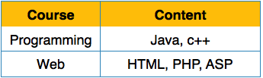
We re-arrange the relation (table) as below, to convert it to First Normal Form.
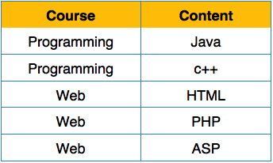
Each attribute must contain only a single value from its pre-defined domain.

Second Normal Form
Before we learn about the second normal form, we need to understand the following −
- Prime attribute − An attribute, which is a part of the prime-key, is known as a prime attribute.
- Non-prime attribute − An attribute, which is not a part of the prime-key, is said to be a non-prime attribute.
If we follow second normal form, then every non-prime attribute should be fully functionally dependent on prime key attribute. That is, if X → A holds, then there should not be any proper subset Y of X, for which Y → A also holds true.
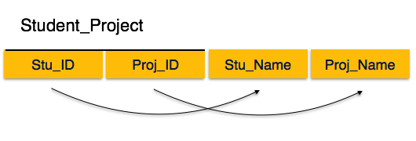
We see here in Student_Project relation that the prime key attributes are Stu_ID and Proj_ID. According to the rule, non-key attributes, i.e. Stu_Name and Proj_Name must be dependent upon both and not on any of the prime key attribute individually. But we find that Stu_Name can be identified by Stu_ID and Proj_Name can be identified by Proj_ID independently. This is called partial dependency, which is not allowed in Second Normal Form.
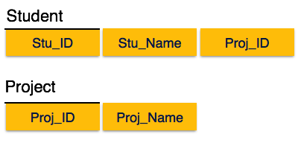
We broke the relation in two as depicted in the above picture. So there exists no partial dependency.

Third Normal Form
For a relation to be in Third Normal Form, it must be in Second Normal form and the following must satisfy −
- No non-prime attribute is transitively dependent on prime key attribute.
- For any non-trivial functional dependency, X → A, then either −
  - X is a superkey or,
  - A is prime attribute.
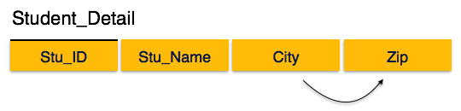
We find that in the above Student_detail relation, Stu_ID is the key and only prime key attribute. We find that City can be identified by Stu_ID as well as Zip itself. Neither Zip is a superkey nor is City a prime attribute. Additionally, Stu_ID → Zip → City, so there exists transitive dependency.
To bring this relation into third normal form, we break the relation into two relations as follows −
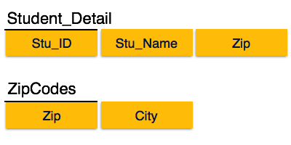

Boyce-Codd Normal Form
Boyce-Codd Normal Form (BCNF) is an extension of Third Normal Form on strict terms. BCNF states that −
- For any non-trivial functional dependency, X → A, X must be a super-key.
In the above image, Stu_ID is the super-key in the relation Student_Detail and Zip is the super-key in the relation ZipCodes. So,
Stu_ID → Stu_Name, Zip
and
Zip → City
Which confirms that both the relations are in BCNF.

Difference between TRUNCATE, DELETE and DROP commands
DELETE
1. DELETE is a DML statement.
2. DELETE removes some rows if WHERE clause is used
3. Can be rolled back
4. Can be used with or without WHERE clause
5. Does not reset identity of the table
6. Triggers will be fired.
7. When DELETE operation is performed, all the data get copied into Rollback Tablespace first,
and then delete operation get performed. Hence we can get back the data by ROLLBACK command.
SYNTAX:
To delete a particular row
DELETE FROM table_name
WHERE column_name = column_value
To delete all rows
DELETE FROM table_name
Or
DELETE * FROM table_name
DROP
1. DROP is a DDL statement.
2. Removes a table from the database. Table structures, indexes, privileges, constraints will
also be removed.
3. Cannot be rolled back
4. No Triggers will be fired.
SYNTAX:
DROP TABLE table_name
TRUNCATE
1. TRUNCATE is a DDL Statement.
2. Removes all rows from a table, but the table structures and its columns, constraints, indexes
remains.
3. Cannot be rolled back
4. Resets the identity of the table
5. Truncate is faster and uses fewer system and transaction log than delete.
6. Cannot use TRUNCATE on a table referenced by a FOREIGN KEY constraint.
7. No Triggers will be fired.
8. Cannot use WHERE conditions
SYNTAX:
TRUNCATE TABLE table_name

DELETE
The DELETE command is used to remove rows from a table. A WHERE clause can be used to only remove some rows. If no WHERE condition is specified, all rows will be removed. After performing a DELETE operation you need to COMMIT or ROLLBACK the transaction to make the change permanent or to undo it. Note that this operation will cause all DELETE triggers on the table to fire.
SQL> SELECT COUNT(*) FROM emp;

COUNT(*)
----------
14

SQL> DELETE FROM emp WHERE job = 'CLERK';

4 rows deleted.

SQL> COMMIT;

Commit complete.

SQL> SELECT COUNT(*) FROM emp;

COUNT(*)
----------
10

TRUNCATE
TRUNCATE removes all rows from a table. The operation cannot be rolled back and no triggers will be fired. As such, TRUCATE is faster and doesn't use as much undo space as a DELETE.
SQL> TRUNCATE TABLE emp;

Table truncated.

SQL> SELECT COUNT(*) FROM emp;

COUNT(*)
----------
0

DROP
The DROP command removes a table from the database. All the tables' rows, indexes and privileges will also be removed. No DML triggers will be fired. The operation cannot be rolled back.
SQL> DROP TABLE emp;

Table dropped.

SQL> SELECT * FROM emp;
SELECT * FROM emp
*
ERROR at line 1:
ORA-00942: table or view does not exist
DROP and TRUNCATE are DDL commands, whereas DELETE is a DML command. Therefore DELETE operations can be rolled back (undone), while DROP and TRUNCATE operations cannot be rolled back.
From Oracle 10g a table can be "undropped". Example:
SQL> FLASHBACK TABLE emp TO BEFORE DROP;

Flashback complete.
PS: DROP and TRUNCATE are DDL commands, whereas DELETE is a DML command. As such, DELETE operations can be rolled back (undone), while DROP and TRUNCATE operations cannot be rolled back.

